Webiste URL : https://www.cw-ems.com/fleet-solutions/markets-and-products/COPPUS-Portable-Ventilators/products/default.aspx

COPPUS® AIR-MAX 12 BLOWER
Economical, High-Volume Tube Axial Blower

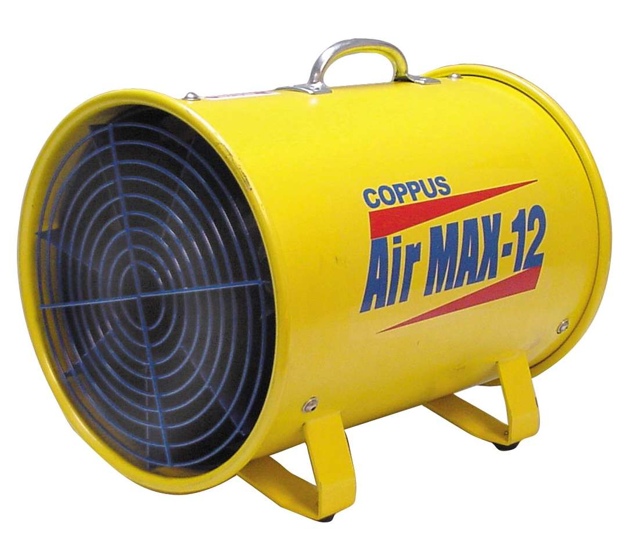
This 12-inch, low profile, rugged blower delivers up to 2,200 CFM for confined space ventilation and fresh air supply.

Features:
- Rugged, all-steel housing construction
- Integral on/off motor switch
- Fixed guide vanes for improved performance
- Glass-reinforced, polypropylene, non-sparking fan blade
- 20-foot cord with GFCI at plug ends
- Anti-vibration foot pads

Specifications :
MOTOR : TE 3/4 HP, with integral on/off switch, 115V/6.8 amp, class B insulation, auto reset thermal overload protection; attached 20-foot heavy-duty cord with GFCI shut-off at plug end.
FREE AIR : 2,200 CFM
WEIGHT : 44 lbs (18.14 kg)
HOUSING : 18-gage steel, powder-coated with carry handle and anti-vibration foot pads;
rolled bead on ends for added strength and attaching flexible ducting;
attached, safety screens per OSHA guidelines.

CFM (m3/hr) Air Flow Through Duct (Straight Runs)
Model | Free Air |  | 10 ft. 3.05 M |  | 20 ft. 6.10 M |  | 30 ft. 9.15 M
Model | cfm | m³/hr | cfm | m³/hr | cfm | m³/hr | cfm | m³/hr
Air Max | 2,200 | 3,740 | 2,120 | 3,602 | 2,025 | 3,440 | 1,890 | 3,211

COPPUS® CADET VANEAXIAL AND CENTRIFUGAL VENTILATORS
Ideal for Utility Underground and Light Industrial Confined Space Ventilation

These versatile, rugged, economical ventilators deliver exceptional airflow in a compact, lightweight design, and their non-corrosive injection molded housing is virtually indestructible. They are ideal for utility underground and light manufacturing confined space ventilation, and are available in a variety of models.

Vaneaxial Models
- Flame-resistant UL94-V2-rated injection molded housing (5VA is the highest UL flame retardant rating possible)
- Glass-filled, polyester resin, spark-resistant fan blade
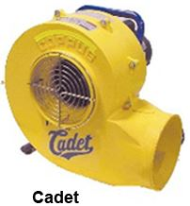
- Accommodates 8-inch flexible duct
- Optional attachable duct canister

Centrifugal Models
- Excellent airflow and pressure performance
- Flame-resistant UL94-V2 injection-molded housing
- Glass-filled, polyester resin spark resistant fan blade
- Accommodates 8-inch duct on inlet and outlet ends
- Fan scroll can be positioned easily at 45 degree, 90 degree and
180 degree discharge positions
- Available in electric and gasoline-driven models

COPPUS® REACTION FANS
Air-Driven Reaction Fans

Rugged, cast aluminum housing and fan blade make these fans ideal for hazardous locations and demanding ventilation projects. The RF design utilizes action-reaction principles; compressed air is discharged through nozzles located at the tip of the fan blades providing extremely efficient, high-volume, low maintenance air movers.

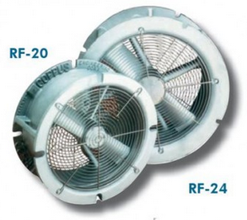
RF-20, RF-24 Features
- For 20 inch (50.8 cm) to 24 inch (60.96 cm) tank man ways
- 11,000 to 16,900 cfm (18,689 to 28,713 m3/hr) at 80 psig
- Use for fresh air supply or fume exhaust
- Can be carried or rolled to job site
- Spark resistant cast aluminum housing and fan blade
- Permanently lubricated bearings
- Flanges mate with 20-inch (508mm) and 24-inch (610mm) API tank opening
- Swing-Out Assembly

RF-12, RF-16 Features
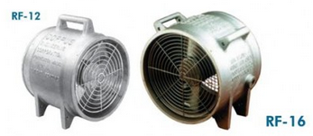
- 2,100 to 5,100 CFM (3,566 to 8,665 m3/hr) at 80 psig
- Use for fresh air supply or fume exhaust
- Low compressed air consumption
- Spark-resistant, cast aluminum housing and fan blade
- Virtually maintenance free
- Permanently lubricated bearings eliminate line oiler
- Cast in handles and feet
- Cast in bead to accept 12-inch and 16-inch duct
- Bolt holes allow attachment of optional adapter plates

COPPUS® DOUBLE-DUTY HEAT KILLER
Powerful Industrial Fan for Cooling Products, Processes and Personnel

With airflows up to 17,000 cfm the Double-duty Heat Killer (DDHK) is one of the most powerful and versatile portable air movers on the market today. The patented, adjustable guide vane design allows air flow control - from a gentle breeze for personnel cooling, to a concentrated jet blast for product and process cooling.

Features
- Adjustable guide vanes allow varied air movement from a gentle breeze to a jet blast
- Available in 18-, 24- and 30-inch (457, 610, 762 mm) models
- 18- (457 mm) and 24-inch (610 mm) models available with optional two speed, totally enclosed motors (115V only)
- Models available in floor stand or wall mount models
- Heavy-duty, rugged steel housing and frame
- Protective screens meet OSHA guidelines
- Available with TE and EP motors
- Hazardous location switches and motors meet NEC Class I, Division I, Group D and Class II, Division I, Groups F and G specifications
- Thermal overload protection on motors

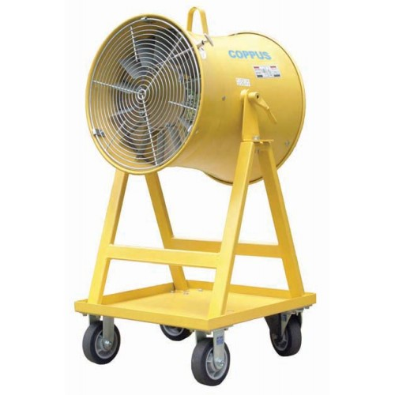

COPPUS® JECTAIR AND HORNET HP
High-Performance, Highly-Efficient Venturi Air Movers

The unmatched performance of the COPPUS Jectair HP is recognized throughout the industry. When compared with older-style air horns, the patented air mixing chamber of the Jectair HP produces up to 26 percent savings on compressed air consumption.

Operating Principle
Compressed air or steam is admitted to the Jectair through a single inlet connection in the housing leading to the mixing chamber. The air or steam jetted from the nozzle creates a Venturi action which induces a large volume of surrounding air to enter the Jectair through the aerodynamic inlet bell. The air is then discharged at high velocity through the horn-shaped diffuser.
NOTE: Operating efficiency depends on compressed air volume and pressure.

Features
- Available in five sizes: 9, 8, 6-HP, 3-HP, 3S-HP
- High-Performance (HP) and Hornet models available in three sizes: 6-HP, 3-HP and 3S-HP
- Air flows range from 1,370 to 8,900 cfm (2,328 to 15,121m3/hr)
- Induction ratios up to 40:1
- Multiple expansion nozzles machined into housing
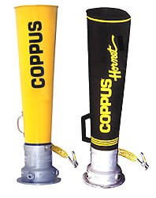
- High static pressure capabilities
- Diffuser material available in steel, aluminum or shock-resistant polymer (Hornet HP)
- No moving parts — virtually maintenance-free
- Static bonding cable with spring tension grip and replaceable contact tips standard on all models
- Accepts flexible duct on diffuser end
- Tripod for stationary mounting available

COPPUS® VANO 175CV, 250CV
Rugged, reliable and versatile ventilators.

COPPUS revolutionized air moving equipment more than 60 years ago with the introduction of theVANO models. The VANO models offer a fixed guide vane design that delivers high volumes of air while maintaining static pressure for exhausting fumes and delivering fresh air. A rugged, durable, high-performance design makes the VANOs ideal for ventilating tanks, process vessels, tank cars, manholes and other confined spaces.

- MODEL 175CV : 3/4 HP, 1,500 cfm (2,549 m3/hr)
- MODEL 250CV : 1 HP, 3,000 cfm (5,098 m3/hr)

Features
- Straightening vanes for improved static pressure performance
- Accepts ducting on inlet and outlet ends
- Available with totally enclosed (TE) or explosion-proof (EP) motors and compatible switch; all single-phase models supplied with 15-foot power cord.
- Heavy-gauge, powder-coated steel and cast aluminum construction
- Spark-resistant fan blades
- Removable sleeve on 175CV and 250CV converts inlet from accepting duct to side-cutout version for exhausting fumes from bottom of tanks
- Automatic reset thermal overload protection standard on VANO 175CV and 250CV models
- Optional tripod and transport cart available

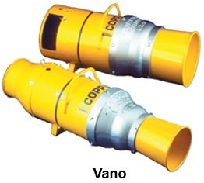

COPPUS® Portable Ventilator Specifications
Product | Motor Type | Fan Size and Type | Air Flows CFM (m3/hr) | Features
Air Max 12 | Electric | 12” (305mm) Vaneaxial | 2,200 (3,735) | Lightweight, compact
Cadet | Electric or gas | 8” (203mm) Vaneaxial | 804-867 (1,358-1,465) | Lightweight, compact
Double Duty Heat Killer | Electric | 24” (610mm) and  30” (762mm) | 7,100-17,000  (12,000-28,890) | Floor mount and optional wall mount
Jectair / Jectair Hornet | Compressed Air | Discharge sizes 8” (203mm) to 14” (356mm) Venturi | 1,370-8,900  (2,328-15,121) | Lightweight, no moving parts, variable flow
Reaction Fans | Compressed Air | 12” (305mm),  16” (406mm) | 2,140-5,100  (3,636-8,665) | Ideal for hazardous locations; all aluminum-cast housing
Reactions Fans | Compressed Air | 20” (508mm),  24” (610mm) | 11,000-16,900 (18,689-28,700) | Flange mount directly to standard API manways
Vano 175 CV, 250 CV | Electric | 8” (203mm) and  12” (305mm) Vanexial | 1,500-3,000  (2,549-5,098) | Rugged, durable, versatile utility air mover

COPPUS® Portable Ventilator Accessories

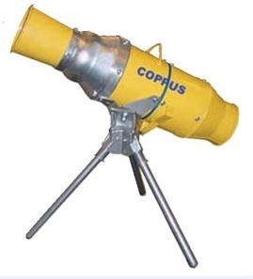
VANO TRIPOD

Attaches to VANO 175CV or 250CV; makes positioning of units and direction of airflow easier by rotating 360 degrees on a 45 degree plane. Spring-loaded legs fold up for easy transport and storage. Weight: 19 lbs (9 kg).

TRANSPORT CART

Vaneaxial and Centrifugal models. These versatile, rugged, economical ventilators
deliver exceptional airflow in a compact, lightweight design, and their non-corrosive
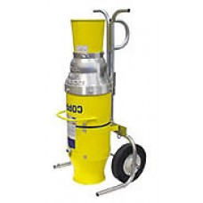
injection molded housing is virtually indestructible.

FLEXIBLE AIR DUCT
COPPUS carries a large selection of flexible air duct for a variety of ventilation application needs. Our most popular heavy duty duct features impregnated polyester duct designed for harsh, industrial environments. Our other selections include: economical light duty duct, source capture duct and hazardous location, anti-static duct.
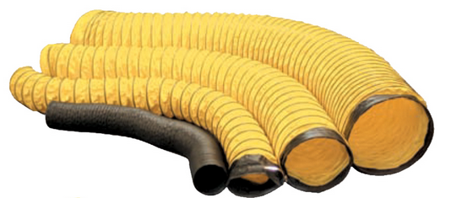
DUCT CANISTER

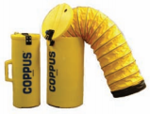
Extend the life of your duct with the protection of a COPPUS high-density, light-weight polyethylene canister; makes transporting and storage easier and safer.
Canisters for duct sizes:
8-inch x 25-inch (203mm x 635mm)
12-inch x 20-inch (305mm x 508mm)
16-inch x 30-inch (406mm x 762mm)

JECTAIR TRIPOD

For stationary, long term use; rotates 360 degrees for precise direction of air flow and accommodates 3HP and 6HP Jectair sizes. Installs quickly and easily with two quick-release clamps. Large feet provide stability during operation and spring-loaded legs fold up for easy transport and storage.
